Total Revenue & Profit Analysis
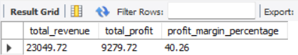
Monthly Revenue & Profit Trend
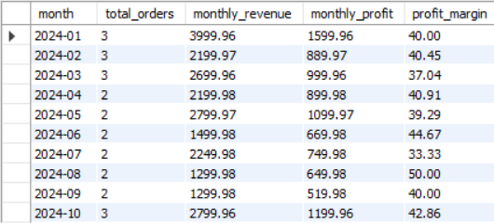
Top 10 Products by Revenue
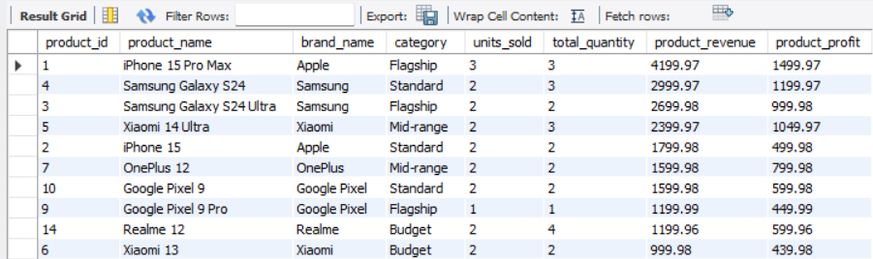

Top 10 Customers by Spending
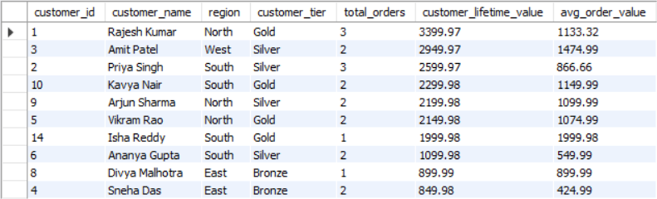

Profit Margin by Product Category
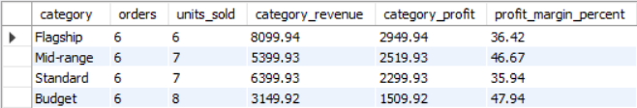

Brand Performance Analysis
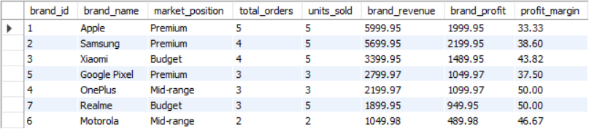

Regional Performance & Trends
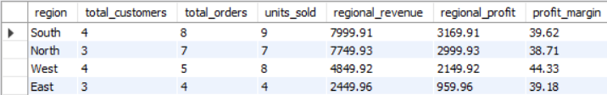

Payment Method Analysis
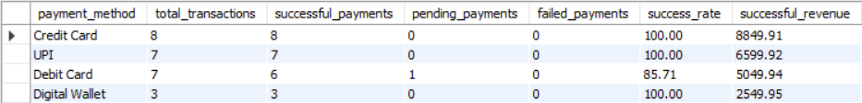

Brand-wise Profit Margin Comparison
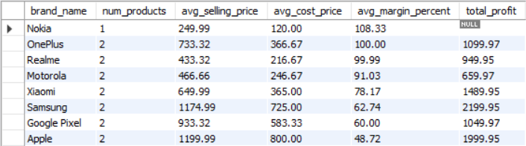

RFM Segmentation (Customer Value Analysis)
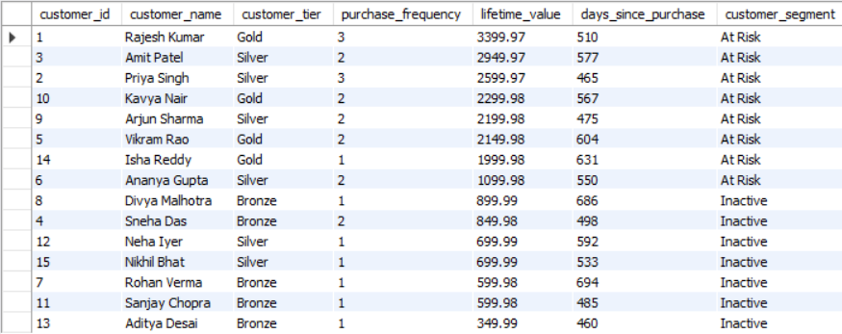
Products Bought Together (Basket Analysis)
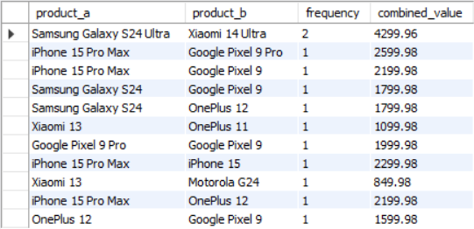

Inventory Stock vs Sales Performance
